Social Studies 9

**RW9.1**

Compare differing perspectives regarding the acquisition and

distribution of resources and wealth in the societies studied.

# CROSS-CURRICULAR OUTCOME(S)

**ENGLI~~S~~H 9**

## **CC9.1A** CREAT~~E~~ VARIOUS V~~I~~SUAL, MULTIMEDIA, ORAL, AND WRITTEN TEXTS THAT EXPLORE IDENTITY (E.G., THE SEARCH FOR SELF ), SOCIAL

RESPONSIBILITY (E.G., OUR SHARED NARRATIVES), AND EFFICACY (E.G., DOING THE RIGHT THING).

**CC9.5A** CREATE AND PRESENT A VARIETY OF

MULTIMEDIA PRESENTATIONS TO BEST REPRESENT MESSAGES FOR AN INTENDED AUDIENCE AND PURPOSE.

## **MATH 9**

### SP9.2 DEMONSTRATE AN UNDERSTANDING OF THE COLLECTION, DISPLAY, AND ANALYSIS OF

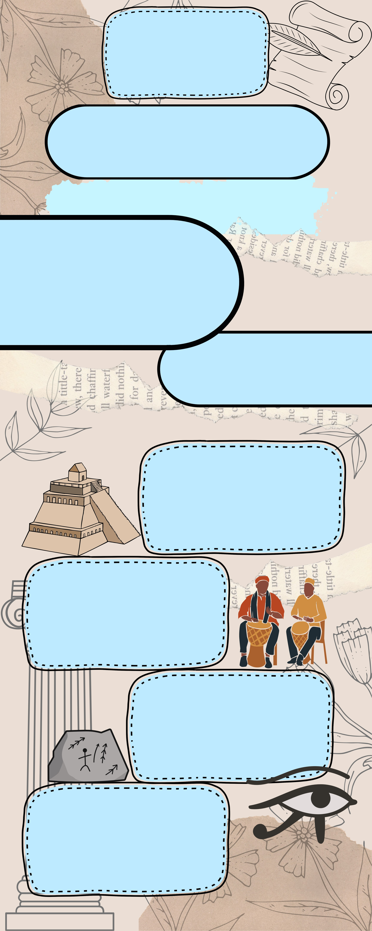DATA THROUGH A PROJECT 4 ~~W~~ays To Teach

### CASE STUDY

Students will pick a society (ancient or modern) and create a case study in any

format (Booklet, website, video, blog, etc.)

The study should investigate the society’s acquisition and distribution of resources, population over time, and so on.

### DEBATE

Students will take sides of differing perspectives for the

acquisition/distribution of resources from

societies studied and compare through debate (ex. Colonizers & Indigenous peoples, Monarchies vs. the people

(Countries - France, Russia, etc.)

### ROLE-PLAYING

Students will choose one society (ancient or modern), and reenact the roles of the people in it. Students will demonstrate how the citizen of their chosen society functions on a daily basis (jobs, wealth, neighbours, etc.)

### MULTIMEDIA PRESENTATION

Students will use a mix of multimediatools

(infographics, posters, blogs, PPT, etc.) to represent a society (ancient or modern).

**Created by: Abigail Giannetta, David Kirwan, Linnette Guderyan, Hayleigh Prentice, Jozelle Sumat**