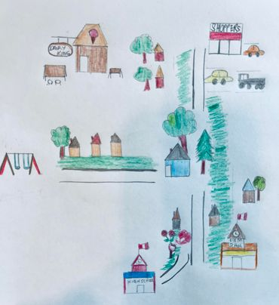
My name is Aizel Mogro; pronouns she/her/hers. I live in Treaty 4 Territory in Swift Current, Saskatchewan. I am a Filipino immigrant. I was born and raised in the Philippines. Growing up, I learned about colonization in the history of my country. We were colonized by Spaniards for more than three hundred years, then came Americans, and last was Japan before we had our independence. My husband and I, together with our eldest son moved to Canada in 2020. Currently, we are living in a neighborhood close to Shoppers, schools, a playground, and an ice cream shop. To the east of our house is the school where I work as an EA. I often walk to school when the weather permits to breathe some fresh air while I enjoy looking at the flowers in the gardens of my neighbors along with some high school students who also live nearby. My kids and I usually bike to our local ice cream shop across the street on hot summer days and enjoy our favorite ice cream. While enjoying my ice cream, I can’t help but think how sweet I knew Canada is, not until I started my Education courses in the University when I became familiar about the bitter history of the Indigenous Peoples. I usually meet First Nations in the park, a block away from our house. My son has a First Nation twin classmates in pre-K, and some white classmates that are usually in the playground every afternoon. When they see each other at the playground, they run, play a lot, shower at the sprinklers. I admire how little kids just play with pure innocence without prejudices. It just gives me hope. As a future educator, I want to build relationships with respect to one another among Indigenous and Non-Indigenous students, hoping to eradicate discrimination, and racism in our society.

