Apple Crisp Procedural Text
Caia Chiverton
University of Regina

How to Make the Perfect Apple Crisp
Introduction:
My mother has taught a few of her most popular baking recipes to both my sister and I, one of them being an incredible apple crisp; an obvious favourite by anyone who has tasted any of my mother’s baking. This recipe is so popular that in the summer while I am at work my coworkers will beg for me to make it for them and when it is made, it only last a few short hours before it is completely demolished. This apple crisp is incredibly sweet and gooey on the inside and has a crispy topping that makes it so addicting. This apple crisp is the perfect dessert to add to any meal and is also a great addition to an afternoon coffee or tea. As described in the Literacy textbook, a written procedure needs an aim or a goal and in this particular procedure, the goal is obviously to create the best tasting apple crisp ever (Winch, 2014, p. 282). My mother has made this recipe quite simple to follow and I am able to share it in an easy recipe with a clear sequence of steps to follow as is recommended by the Literacy textbook for important features of a procedural text (Winch, 2014, p. 282). Another important aspect outlined in the Literacy textbook is stating the required materials/equipment needed and in this recipe the ingredients/materials needed are all quite easy to find and most likely already things people have in their kitchen (Winch, 2014, p. 282). This apple crisp can be done using any type of apple and can be done with the apples peeled of unpeeled, depending on what a person’s preference is. Personally, I like to use Gala apples and I usually leave the skin on. The best part about this apple crisp is that it tastes delicious fresh and hot out of the oven with a side of vanilla ice cream or over the next few days when it has cooled. To preserve this apple crisp after it has been baked, simply cover with tin foil and store on the counter or in your fridge. However, as I mentioned before, this apple crisp typically does not last very long because it is quickly eaten up so it is likely going to be eaten while hot.

Aim (goal): To create a delicious apple crisp.
Baking Materials:
- One microwave safe 9x13 pan
- Measuring cups
- Measuring spoons (Tsp and Tbsp.)
- Mixing spoon
- Large mixing bowl
- Microwave
- Vanilla ice cream
Ingredients:
For inside the crisp:
- 5 cups of cut apples with the core removed (approximately 5 apples)
- 2 cups of white sugar
- 1 tsp of ground cinnamon
- 2 tbsp. of all-purpose flour

For the topping:
- 2 cups of oats
- 2 cups of brown sugar
- 2 cups of all-purpose flour
- 2 cups of melted butter
- ½ tsp of baking powder
Instructions:
- Preheat the oven to 350°F.
- Begin by cutting the apples into thin, even slices.
- Place the apples evenly across the 9x13 pan.
- Add 2 cups of white sugar on top of the apples in the pan.
- Sprinkle 1 tsp of cinnamon over the apples.
- Add 2 tbsp. of all-purpose flour to the pan.
- Soften the apples by heating the pan in a microwave for 7-10 minutes.
- Softening the apples in the microwave is not mandatory but it reduces the amount of time the apple crisp will need to be baked and ensures the apples will be soft.
- Check on the apples after the 5 minutes and give them a gentle stir and then place the pan back in the microwave.
- While the apples soften, add all the ingredients for the topping in a large mixing bowl.
- Add 2 cups of dry oatmeal to the bowl.
- Add 2 cups of brown sugar.
- Add 2 cups of all-purpose flour.
- Carefully measure and add ½ tsp of baking soda.
- Carefully measure and add ½ tsp of baking soda.
- Melt 2 cups of butter in the microwave
- Slowly pour the 2 cups of melted butter to the dry ingredients.
- It works best if one person pours while another person begins to stir.
- Mix all the ingredients in the bowl together until evenly mixed and noticeably crumbling.
- The ingredients need to look damp and slightly together but there should not be any large clumps.
- Take the pan of apples out of the microwave and stir carefully.
- Evenly place the topping across the warmed apples.
- Smooth out the topping but do not pack it down.
- Place the pan with the apple crisp into the oven.
- Allow apple crisp to bake for 30-35 minutes.
- The apple crisp should be slightly browned on top and have the juices bubbling in the corners.
- If there are no juices bubbling on the corners at the top, the apple crisp needs to go back in the over for a couple minutes.
- Take the apple crisp out and allow to cool.
- Dig in, add vanilla ice cream and enjoy!
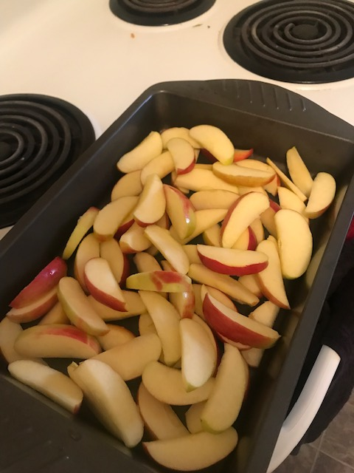
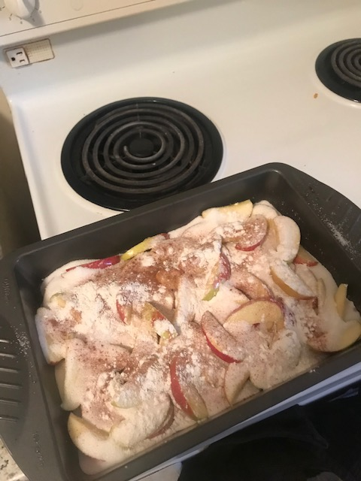

The apples sliced The sugar, apples, cinnamon and flour

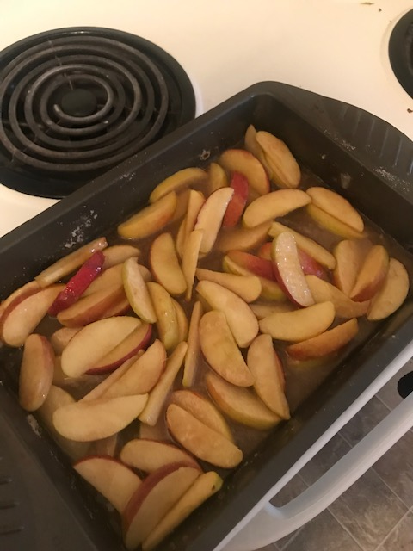
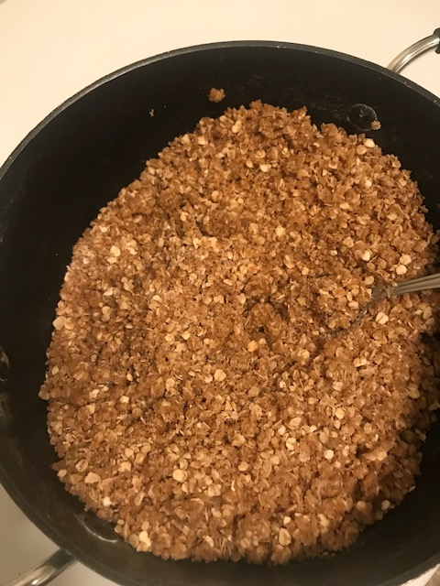

After being heated and softened The ingredients for the topping mixed together

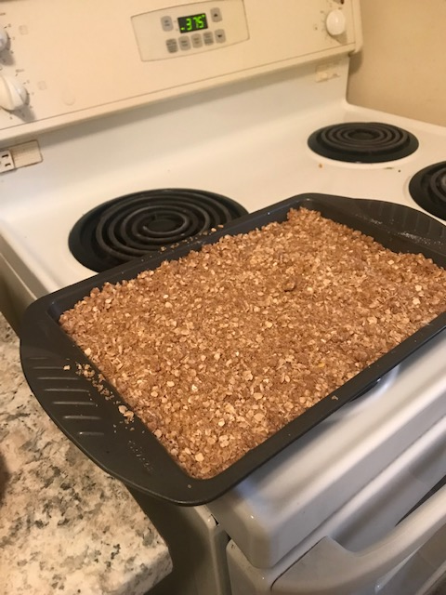

The apple crisp ready to go in the oven

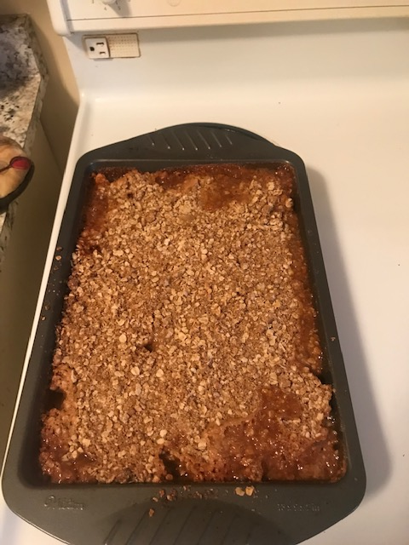

The finished product, ready to be eaten!
Work Cited
Winch, G., Johnston, R. R., March, P., Ljungdahl, L., & Holliday, M. (2014). Leteracy: Reading, Writing and Children's Literature. South Melbourne: Oxford University Press.

