Caia Chiverton
EHE 310
Donna Nikiforuk
October 15, 2018

Theory to Practice
Topic:

Outcome 7.6 - “Develop interpersonal skills, including assertiveness skills, to effectively and skillfully manage peer pressure”

The types of topics that can be covered in this outcome include alcohol and drugs, exclusionary behaviours, family expectations, academic pressures and rules/laws. One goal for this outcome is for students to understand the difference between assertive, aggressive and passive behaviours and how to confidently deal with the pressures they will be faced with in their daily lives. Students should be able to identify different types of pressures and understand the negative/positive consequences to the choices they make. Students will be able to describe and demonstrate at least 5 different strategies for resisting peer pressure; these strategies include saying no, providing an excuse, using humour, etc. Students will become more socially aware by examining topics such as harassment and discover similarities and differences in peer pressures faced by different genders, socio-economic backgrounds, family structures, sexual orientations, ages, and cultures.

Successfully covering this topic should help students not only learn the skills required to deal with peer and social pressures in their lives, but also help mold them into being more mindful about the decisions they make and how they treat others.

Activity 1: Peer Pressure Introductory Demonstration

This is an activity that can be done at the very beginning of the peer pressure unit as an interesting and fun way to introduce the concept of peer pressure and demonstrate to a grade 7 class how easy it is for teens to be pressured by their peers.

Allow students to mingle with one another at the beginning of the class, giving them time to chat and sit with one another. During this time, one teen will be sent out of the class on a random errand for the teacher. When the student leaves, tell the rest of the students that you are doing an experiment to see how the student who left will react. You can get the students in the class to all do the same pose or have them all behave in a way that is atypical in the classroom and therefore easily noticeable. For example the students could all sit facing the back of the room or on top of their desks. When the student who left returns to the class, the teacher needs to behave normally and act as though they don’t really notice what is going on. Watch what the student does, will they join their peers in their atypical behaviour or will they go against the crowd? If the student does what the rest of the class is doing, this helps begin a great discussion on how teens often go along with what the rest of their peers are doing without really questioning the logic of it because it is much easier to always try to fit in with the crowd. If the student refuses to join the crowd, you can have them explain why they chose that option and still use it as a great teaching moment to show that life is about choices and you don’t always need to do something just because everyone around you is doing it.

This activity is lighthearted and simple to do but provides a great opportunity for students to start thinking and talking more about peer pressure and what it looks like, how they are affected by it in their daily lives and really begin to think more deeply about why they do the things they do.

Tips for the activity:

- Don’t stare at the student when they return from doing the random errand
- Go about class normally when the student returns (take attendance or do something you’d regularly do)
- If the student asks any questions when they enter the room just shrug and don’t make a big deal about it
- The errand you send the student on should take at least 1 minute to give you enough time to get the other students involved and set up in the activity
- Choose the student wisely. The student should be someone who won’t be upset if you use them as a learning example and should be someone who won’t spend the entire class wandering the halls.

Discussion questions:

- Ask the student why they did or didn’t do the behaviour their peers were doing
- Ask the class to raise their hand if they would have done what everyone else was doing and why. Then ask if they think they would have done something differently
- Ask students if they have ever done something just because everyone else was doing it and allow for some examples to be given and talked about

From this activity students will learn that peer pressure can be experienced in many different ways and provide an example of how often students don’t even realize they are experiencing it. In this outcome they will learn much more about different types of peer pressure and be given effective tools and strategies on how to deal with it but this quick activity provides an opportunity for those conversations to start.

Activity 2: Introducing Different Types of Peer pressure

The goal of this activity is to show students that peer pressure can look differently in different situations and allow them to understand how certain actions they do can make others feel.
Peer pressure can be very subtle, which makes it hard for some students to recognize. More obvious peer pressure can still be challenging for students to be critical about, because they are trying so hard to fit in. A good way to teach students to recognize and respond to peer pressure is to create role plays in the classroom where the situation is safe. You can create role play scenarios with different types of peer pressure so students learn how to identify and respond to them.

1. Normative Social Pressure

Normative social pressure is a type of peer pressure that influences people to conform to a group. For example, when a group of students is doing something or have something that seems cool and interesting, others may want to do or own the same thing to fit into the group. Students are not directly pressured to fit in but feel the need to conform.

For this role play, you need two groups to commit to the roles. The first needs to be 4-6 students that have the newest technology such as an IPhone. They can be sitting and playing with them, laughing and showing each other the neat things that their phones do. The students not involved in the role-play can explain how they feel about the students and their cool phones. Then do the exact same role-play, but replace the phones with fake cigarettes or alcohol to show students that the desire to be in that “fun” crowd is still the same, but could lead to negative consequences.

2. Rejection Peer Pressure

Rejection peer pressure involves students being turned down for friendship or activities because they are not cool enough or a specific type of person.

For this role play, place sticky notes under half of the chairs before class starts. Then when the students come in, have them choose their own seat. Once all of the students are seated, have them look under the chair to see who has the sticky note. Tell them that those with a sticky note will get a prize after class, while those without a sticky note will not. At this point, you will have half a class that is happy, and another half that is not.

Now make groups that comprise of two prize-winning students and two students who did not have a sticky note. Have them all act out a rejection role play about two students that exclude two other students from a night out. Watch the behavior from both sets of students to see how the prize winning changes their behavior. You might find that you have two students who are happy and active in the event, and two who are grumpy. Once the role play is over, explain that everyone actually gets a prize and explain rejection peer pressure and the reasoning behind your set up.

3. Insult and Influential Peer Pressure

Insult peer pressure is common in school because kids call each other names or bully one another. However, kids can be desensitized to this and not recognize it for what it is, so it is important to show the realities of this type of peer pressure.

In this role play, have students break into groups of 5-6. Then have them choose a subject, such as alcohol, drugs, smoking, and/or bullying others. After the groups split up, go to each group and tap the shoulder of the person who is going to say no. At this point have the students’ show how they would try to influence that student to start drinking or smoking. Make sure their name calling is not too intense; instead have them focus on influential insults such as ''If you don't drink you are never going to be invited to the party, because you're uncool.'' These aren't violent insults but are still impactful.

To make the activity more impactful, have a black sheet or blanket set up like a fake wall, so the role-players can act behind the blanket, while the rest of the class just listens to the nasty repertoire. Once each group finishes, have the students who were listening voice their feelings. Since the students were not distracted by visual cues, they could focus more on what is being said. This helps students see how intense insults can be.

4. Non-Verbal Peer Pressure

Although non-verbal peer pressure is more subtle, it can still hurt students. So it is important to bring this to their attention.

For this role play, take 4-5 students out of class and have them wait. Then go back to the rest of the class and have them break out into groups of 4-5. Give each group a different non-visual cue to do. One group can be the eye rollers who stand around and roll their eyes at the student coming into their group. Another group can be the huddlers who stand in a huddle looking at laughing at something and not letting the new student in. Another can be the sighers who just sigh in a rude and disgusted manner at the student coming into the group. Once all the groups have their roles, bring the other students back in and assign them to go join a group. As the new students get more awkward and uncomfortable and truly understand they are being excluded, stop the role play. This is enough to give the students an idea of how hurtful non-verbal peer pressure can be.

Group Discussion:

These role play scenarios can be done and then allow for meaningful discussion to take place. Students can describe how they felt in each scenario and how it felt to be in the different roles that they played. Students will gain better insight into what peer pressure is and how there is more than one type of peer pressure they can experience in real life.

Notes for language:

- Some of these words about the types of peer pressure may be new to students so it is important that the terms such as “normative” and “rejection” are explained in depth and fully understood by students.
- To make the terms easily understood a teacher should give plenty examples of what the types of peer pressure look like/sound like. For example, rejection may be leaving people out, saying no to others just to be mean, running away/hiding from someone, etc.
- Remind students that during role playing, they need to still remain school appropriate, therefore swearing and derogatory terms are NOT allowed

Activity 3: The Silliest Response

This activity is sort of like the popular card game Apples to Apples.

- First, you will need to make up a variety of cards featuring peer pressure scenarios and phrases like 'Cheating on the math test is ok, because they make it too challenging,' or 'Have a drink! My parents say it’s ok, and it's fun!'

- Second, you will need to make up silly responses students can use to resist or deflect peer pressure. For example, 'Drinking makes me cuddle with the dog, and he slobbers, so no.' or 'Nah, smoking gives me bad breath and makes my teeth fall out!' The more ridiculous the better.

- You can also leave some blank cards to allow students to think of their own creative responses and add them to the pile of possible responses.

- Then, have the kids sit down in groups of five or more. Each student should have 5 response cards, while the scenario cards go in the center. One person draws the first scenario card and reads it out loud to the group. Then, each student chooses the best answer from their own cards and places it face down in front of the reader. The reader then reads all the responses and chooses the best one.

- The teaching point of this is to provide silly but effective ways for students to say no to peer pressure.

Students will become more familiar with all the different types of peer pressure phrases they may encounter someday and learn that deflecting peer pressure is very possible and can be something they get very skilled at doing.

Activity 4: The Recruiting Game

To begin, tell learners that they will be playing a game to see how good their powers of persuasion and resistance are. Ask for six learners to volunteer to be ‘recruiters’ for the game. (If your class is particularly small, you may want to reduce the number of ‘recruiters’) Ask each ‘recruiter’ to pick a ‘mission’ card for one of these listed groups:

• The Smoking Group - this group wants to recruit others to start smoking.

• The Drinking Group - this group wants to recruit others to start drinking alcohol.

• The Missing Class Group – this group wants to recruit others to skip classes.

• The Volunteering Group – this group wants to recruit others to volunteer at the animal shelter

• The Running Group – this group wants to recruit others to join their running group

• The Study Group – this group wants to recruit others to join their study group

Tell the ‘recruiters’ not to share their mission with other learners yet. Explain to the ‘recruiters’ that it is their job to think of ways to persuade the other learners to join their group. Give them a few minutes to think about their ‘pitch’ and to prepare how they will try to persuade their peers to join their group. Have the other learners in the class spread themselves out across the classroom. When the game begins, the ‘recruiters’ must go around the classroom trying to convince their peers to join their group by using persuasive arguments. If a learner is convinced to join the group, then that person walks with the ‘recruiter’ and has to help the leader to recruit more people to the group. If a learner does not want to join the group, they should resist the arguments of the recruiters with their own counterarguments.

Explain to the class that they have fifteen minutes to recruit as many learners as possible, after which the recruits in each group will be counted and the winner announced. After the recruitment activity is completed and the winning group identified, bring the class back together to debrief the activity.

Ask the class the following questions:

a. How did the leader and the other members of the group try to persuade others to join the group? What strategies did the group use?
b. How easy was it to persuade others to join the group?
c. What were some of the reasons people gave for not wanting to be recruited?
d. How did someone feel if they refused to join a group?
e. How did the ‘recruiters’ feel when their efforts were refused?
f. Was it easier to recruit others once there were more members already in the group?
g. Where there any strategy that were especially successful in pressurising to join a specific group? What were these?

Explain to learners that although this activity is just a role-playing game, peer pressure is something that happens in real life. Wrap up the activity by asking them to reflect on their own experiences of peer pressure, and what can be done to resist it. The following questions can be used to stimulate this discussion:

a. What kinds of techniques are used to pressure peers into doing what they don’t want to?
b. How does it feel to be pressured into doing something in this way?
c. What can we say to our friends when we don’t want to do something that they want us to do?

This activity is a good way for students to understand the difference between positive and negative peer pressure. Not all peer pressure is bad, sometimes students can influence each other in making good and/or healthy choices. Students will learn how to say yes or no to things that they agree/disagree with.

Activity #5 – Influential Words

Tell students to choose one quotation from the list of influential quotes below or choose another quotation that relates to peer pressure. Write a paragraph about the meaning of the quotation, especially as it relates to a peer pressure experience you’ve had, read about, or learned about from a friend/sibling/relative.

Notes on language:
- The word “influential” may need to first be explained to students
- Students will need to understand what influential means and why certain quotes are often used for motivation or teaching lessons
- Another term you could possibly use is “meaningful”
- The teacher can ask students whether they have a favourite quote and what it means to them
- Students should be encouraged to choose a quote that has meaning to them and that they fully understand

Possible Quote Options:

“Be who you are and say what you feel, because those who mind don’t matter and those who matter don’t mind.” - Dr. Seuss

“Don’t think you’re on the right road just because it’s a well-beaten path.” - Unknown

“Those who stand for nothing fall for anything.” – Alexander Hamilton

“One who walks in another’s tracks leaves no footprints.” – Proverb

“If 50 million people say a foolish thing, it is still a foolish thing.” – Anatole France

“Yield to all and you will soon have nothing to yield.” – Aesop

“If everyone is thinking alike, then somebody isn’t thinking.” – George S. Patton

“You don’t get harmony when everyone sings the same note.” – Doug Floyd

“Only surround yourself with people who lift you higher.” - Oprah Winfrey

“The true test of a man’s character is what he does when no one is watching.” – John Wooden

Students will be able to share a personal story they’ve experienced with peer pressure or think about something they’ve heard about happening before and apply it to one of the quotations. This activity will get students to think more deeply about these influential quotes and critique the peer pressure in their own lives and hopefully gain insight into why following the crowd is not always a good choice.

Activity 6: Comic Strip

Get students to think of any negative peer pressure situation they may have experienced themselves or can imagine and have them create and design a short comic strip about that situation and how it was handled. Students will need to create their own comic dialogue and be able to address what type of peer pressure is being exemplified and how their characters will handle it. The comic should be between 6-10 frames long and it should be clearly understood what is happening in each frame through the use of pictures, details and dialogue. Students will most likely need to see an example so they know what the teacher is looking for. They can follow the example but encourage them to think of their own original scenario. To help students think of ideas you can remind them about what types of peer pressure there is, what people are pressured about and the types of skills they can use when handling the situation.

Types of peer pressure:
- Normative Social Pressure
- Non-verbal Peer Pressure
- Insult or Influential Peer Pressure
- Rejection Peer Pressure

Things people get pressured about:
- Drinking alcohol
- Skipping class
- Trying drugs
- Smoking cigarettes
- Bullying another student
- Helping a peer cheat on a test or assignment

How to handle the situation:
- Make an excuse
- Say no
- Walk away from the situation
- Use humour
- Explain why that doesn’t interest you

*Remind students that the dialogue used in the comics needs to be school appropriate.

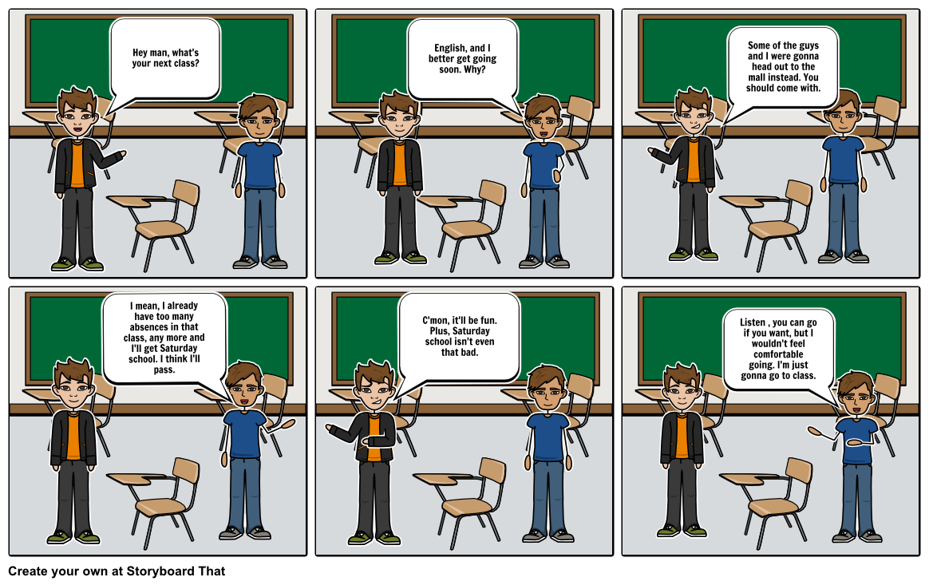
Here is an example of a peer pressure comic strip that students can generate ideas from.
This activity allows students to be creative but also demonstrates that they understand different types of peer pressure and shows that they are aware of ways to deal with peer pressure confidently
Activity #7: Peer Pressure video

Students will create a 5-7 minute video about what they have learned about peer pressure and what they want others to know. Students will have full creative freedom to decide how they want to present their ideas as long as it is school appropriate and related to peer pressure in some way. The students can pick their own groups of a maximum of 4-5 students or work alone/in pairs.

Some ideas a teacher can give students for their video:

1. Create a video that you can show an elementary class to help teach young students about peer pressure (age appropriate)

2. Make a documentary styled video that presents how peer pressure is a problem in middle school

3. Make a “how to” video and present different fun/effective ways on “how to” deal with peer pressure

4. Make a short film. Have characters, a storyline, and script that tells a story about peer pressure.

5. Videotape a puppet show/figurines or toys as a way of talking about peer pressure

6. Conduct video interviews with different people to learn how peer pressure impacts their lives

7. Make a music video about peer pressure.

8. Do a news report about peer pressure. You could find facts about peer pressure and discuss problems peer pressure is creating around the world/in your school

9. Make an advertisement that shows how peer pressure is good/bad and try to sell the class on why they should/shouldn’t take part in it

10. Create a dance/poem/song about peer pressure and video tape your group performing it

The teacher can give plenty of class time for students to work on this project. It is a great project because it is interdisciplinary; students will develop technological skills, writing and speaking skills as well developing their interpersonal skills for effectively dealing with peer pressure. Encourage students to be creative and have fun!!

Activity #8: Pressure that Helps Me, Pressure that Hurts Me

For this activity, students will be given a large piece of paper. In the middle of the page the students will draw a self-portrait of themselves. On the left side of the page they well put the words “Pressures that help me” and on the right side of the page they will put “Pressures that hurt me”. The students will then fill the page accordingly with all types of pressures that hurt or help them.
For example on the “help me” side they could draw pictures of their favourite sport or positive activities they do with their friends. On the right side, students could draw pictures of alcohol or smoking. Students could even show unhealthy lungs from smoking on the right side of their body compared to the healthy lungs on the left side of their body from playing sports. Students can include cut out pictures from magazines or include printed pictures they get from the internet; they have the freedom to make this self-portrait their own representation of themselves and the pressures they are faced with in their lives.
Students should be encouraged to fill the page with as many positive and negative pressures that they can think of and make it as colourful and visually appealing as possible. This is an individual activity, so remind students that what they include in their picture is probably going to be different than what their peers have on their paper, and that is what makes them all unique and special.
These portraits can be hung in the classroom and students will be able to see what their peers made and be proud of the work they created about themselves.

Activity #9 – Children’s Book Response
Students will be placed in small groups of 5-6 students. Together the students will read a short picture book that relates to the topic of peer pressure. The students will then discuss the book together and individually make a response to what the book is trying to teach to young students and determine how this book could be used to teach others about peer pressure. Students will identify what type of peer pressure is being presented and how the characters dealt with the pressure. Students can determine whether the pressure was dealt with appropriately or if they would do something differently and provide any advice they would give to the character in the book. Students can create questions they can ask readers to help them make connections to the book. This is an activity that gets students to think critically about a book and begin to think about how they could teach others about peer pressure. The teacher will supply the books and allow the groups to choose the book they want to read.
Possible book options are listed below:

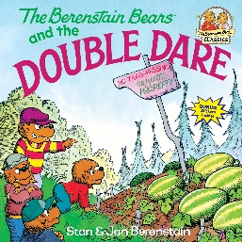
1. The Berenstain Bears and the Double Dare

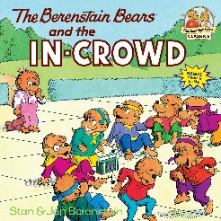
2. The Berenstain Bears and the In-Crowd

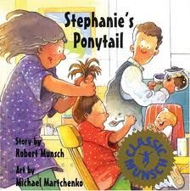
3. Stephanie’s Ponytail

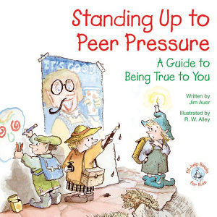
4. Standing up to Peer Pressure: A Guide to Being True to You

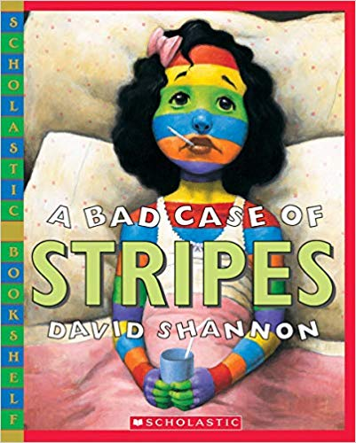

5. A Bad Case of Stripes

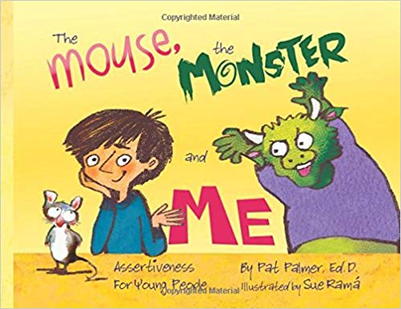
6. The Mouse, the Monster and Me

The students will need to work collectively in their small groups to discuss the books and create meaningful connections between the stories and real life situations. The books are for children but still have important messages in them and the students need to problem solve and discuss out loud what they can take from each book and share with others through their individual responses they will write.
Resources used:

Activity 1: Peer Pressure Introductory Demonstration
Idea retrieved from
https://www.pecentral.org/lessonideas/ViewLesson.asp?ID=11018#.W8TtOmhKhPZ

Activity 2: Introducing Different Types of Peer Pressure
Idea retrieved from
https://study.com/academy/lesson/peer-pressure-classroom-role-plays.html\

Activity 3: Silliest Response
Idea retrieved from
https://study.com/academy/lesson/peer-pressure-games-activities.html

Activity 4: The Recruiting Game
Idea retrieved from
http://www.ghjru.uct.ac.za/sites/default/files/image_tool/images/242/schools/Ch4/CH4_EX5_Final.pdf

Activity 5: Influential Words
Idea retrieved from
https://classroom.kidshealth.org/classroom/9to12/personal/growing/peer_pressure.pdf

