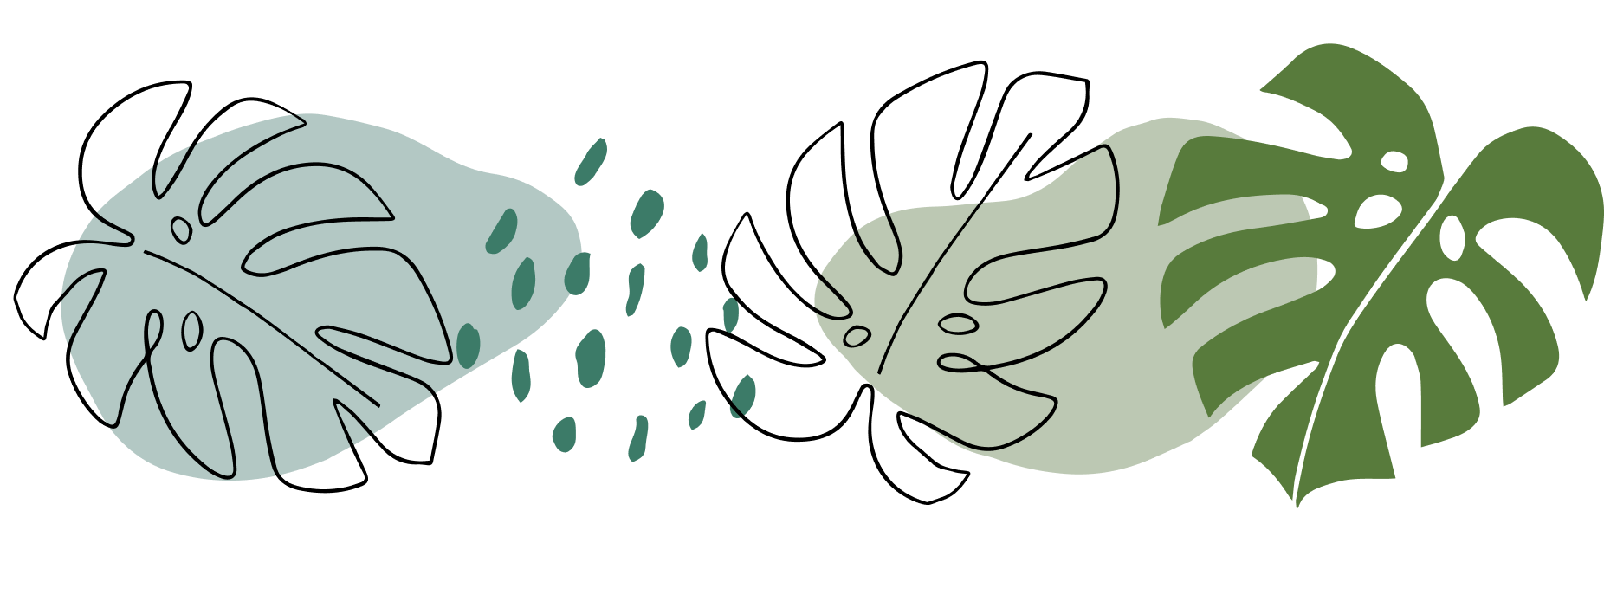

My Autobiography
Kari Mcnabb
ECS 101 397
January 18, 2022

So obviously my name is Kari but my full name is Kari Jayde McNabb, which my parents surprisingly picked at random and has no specific reason why they chose it but it does mean pure/kind. I mainly grew up in the small town of Alameda but I've moved around a little bit when I was younger, and now live on an acreage. My immediate family is fairly small with just my mom, dad, younger sister and dog; but my extended family is quite big with my 5 aunts, 6 uncles and a bunch of cousins. With my big family, holidays or anytime I get to spend with family tends to be my favorite thing to do especially if I get to see my grandpa (moms dad). He is quite literally one of my favorite people ever and is the only person I would say I look up to. I also have two main groups of friends, one being my girl group that has my best friend of 16 years in it, and the other being my guy group. I was born May 22, 2003 so that makes me 18 turning 19 and a Gemini which I think is an important thing to know as it does explain a good amount of my personality.
My identity/personality has changed a lot over time, as one should, and I can say that I like who I am now and can appreciate all that I’ve been through that has got me here. Some defining things about me is that I am a very honest person and that I am a very stubborn person, but I have been told that I act like a mom sometimes when it comes to my friends. I’ve been told that I am a hard worker sand while I am most times it is out of spite which I will explain later. While I grew up my parents drilled being a hard worker into me as well as not doing stupid things outside of being a regular kid; what I mean by that is there were a lot of kids around me doing really stupid/bad things and they didn’t want me to be like that so while I did do kid things, it was mostly just me living life. Another belief that my parents drilled into me was being good with my money, this stems from my dad being a banker and working with money. Another thing that became part of my identity is not caring how people chose to live their lives just as long as they respected my decisions and I respected theirs which stems from my parents never caring what I did with my life as long as I was happy and again not making stupid decisions. The trend here being that my parents just wanted me to be a good person and not go through life making dumb decisions which I believe is exactly how I turned out. The schools I went to were pretty good schools and helped shape me. I would regularly help out around the school volunteering a lot, I was in the volleyball club and yearbook, and I was a good student; however, I was picked on quite a bit by the boys in my class and I was even picked on by one the teachers we had staffed at the school. There was a huge incident with me and her, and I basically started a school rally (as bad as it sounds it was for a good reason, I loved all my other teachers and my school and felt really bad about this but it needed to be done). Despite being a good student in middle school, nobody thought I would make it far or get good grades in high school so I took all that and out of spite became a 95 average student in high school that excelled at sciences/math which is what my major/minor is. Why I initially chose to become an educator wasn’t me wanting to change the world or make a difference (though I will still try to make a difference in my students lives as an educator) but me wanting to do something in the science field just to prove I could. I originally wanted to go into Botany but after doing research on it I decided it was not the field for me and chose to go down the chemistry path; so, because I didn’t want to be a scientist, I decided to be a teacher. What also helped me come to this conclusion of wanting to be an educator was the show MythBusters, I watched this show all the time and the experiments they did always fascinated me and I wanted to give students a chance to do cool experiments in school. I chose Regina as my place of schooling because this university always fascinated me and I immediately knew I wanted to come here.
I decided all of this in grade 8/9 and stuck to it never changing and focused on learning anything I could that might help me, which is why I worked in a ton of leadership positions (lifeguard, swim instructor, daycare educator, coach, tutor) so I could prepare myself for a job in education. I may not have had the most philosophical reason as to why I wanted to become a teacher but I am so excited to one day have my own classroom and be able to share my knowledge with students. Becoming a teacher was not my first choice but is now the only thing my heart is set on doing and I want to become that teacher that her students can confide in, and the type of teacher that all the parents hear about and is glad to have their child in my classes. My goal right now is to become that person that makes a difference with her students and so that when I’m older I can look back and be able to tell anyone who doubted me that they were wrong.

