**Journey Towards Reconciliation**

**Carlos Martinez**

**ECS 101**

**November 22 2021**

**Julie Machnaik**

In my journey towards reconciliation, I have gained a wealth of knowledge this year that I previously did not have before this first semester. On the “Office of the Treaty Commissioner” website it states that in our present day, reconciliation is no longer an idea, it is happening all around us. Personally, only now have I really believed that this is finally true. Our country making amends for the tragedies that has happened is no longer just a talking point for our society; we are finally taking action. Throughout this first year of university for me, it has been a learning experience in many different ways. I have been introduced to many different perspectives from fellow students or teachers, learned about many new concepts and how they affect our world. Growing up as a person of color and an immigrant, I found it easier at times to relate to indigenous youth my age. Often going through the same struggles, I was quicker to make a connection with kids from a similar background to myself. The more I learned about how complex issues on race, poverty, equality/equity and similar factors can be, I became more confident in branching out to new friend groups, meeting new people and being less guarded without fear of being judged.

Growing up I was around friends of first nations descent and their family members as they told stories on the injustices that have occurred to their people in Canada. As we got older friends would share stories their parents, uncles, aunts, kookums and mushums would tell them. Stories of sexual abuse, stories of physical abuse as a means of punishment for bad behaviour, and the mental anguish that they experienced which has lasted to the present day. Having seen some of the effects this has had on some people like bringing them to drug or alcohol abuse to cope with their feelings, it is a powerful thing to see people recover and try to come to terms with this past. Part of my own learning experience in university has been realizing how many people have really never learned about any of these topics throughout their lives. It was a bit shocking to me in some class discussions that we had, some students would say this was the first or one of the first times they have heard or read about some of the things that have happened to indigenous people. I do remember not learning much about these topics in the school system growing up but it was still very surprising to me that the history of this country was not well known amongst some young Canadians.

My personal views on race relations were on the negative side growing up in my neighbourhood. There was a lot of people of color that I came up with, immigrants from different countries and we all related to each other. Often the mentality for us was “us vs them” or minorities vs white people, at times getting those feeling reinforced by comments made by a class mate or adult. It was not a very good feeling for me as I am not a person that enjoys conflict, my parents always taught me from a young age to be kind, helpful and a good person to others. As I grew up, I was an avid reader, if I was curious about anything I would read as much as I could about it. Over time, absorbing more and more information about the world, I came to realize that having an “us vs them” mentality was not the right way to approach the issues of race and inequality. Painting people with a broad brush is what those who have been marginalized have been fighting against in North America.

I believe that reconciliation for the indigenous people of our country is a journey with many steps. As a future teacher, I believe that it is crucial from a young age to teach unbiased history to students. Not one side of history or just the victors side, but every side. It is clear now that it is not enough for our society to acknowledge the wrongs of the past but we must also do all we can to educate future generations on our history. In our present day we have finally began to make advancements, as shown with us recently having our first National Day of Reconciliation. However, issues of poverty, mental health, substance abuse, racism, abuse, and many others must also be addressed as they are fallout from the trauma experienced by Indigenous people. This trauma is then passed down from generation to generation. In my own journey I will do my best to educate students on these topics, giving them all the resources possible to do their own research on our countries past.

I am a strong believer in taking different approaches to learning, approaching things from another perspective can show students a different view that they may not have seen before. As we know now humans learn in various ways, some more receptive to the classical way of learning but there may be some who do not adapt well to that style. Keeping that in mind is important when creating/nurturing your classroom environment. I believe trying different forms of assessment, aside from standard testing practices, would be beneficial for students. Being aware of the physical settings of your classroom is also a key part of being a teacher. As we have learned school is not just a place, it is a place of social interactions. We must create spaces for students that can be shared and are welcoming, places that can be moved and adjusted as the classroom needs.

In my future in teaching, I will draw from what I have learned in this class with hopes of incorporating different ways of learning and doing in the classroom. The topics covered have begun the foundation of my teaching journey and I will do my best to build from that during my life. I know that my own journey is still developing and there is a world of knowledge out there to absorb. Learning about the different power dynamics that go on in the classroom, I will strive to be conscious of those factors in the future and in my decision making as a teacher. My hope is to have an inclusive classroom where students can feel respected, one where students can feel like they can approach me at any time and feel comfortable doing so.

**References**

<https://urcourses.uregina.ca/pluginfile.php/2532140/mod_resource/content/0/TRC%20booklet.pdf>

<http://www.otc.ca/>

<https://residentialschoolsatlas.org/index.html>

<https://www2.uregina.ca/education/saskindianresidentialschools/>

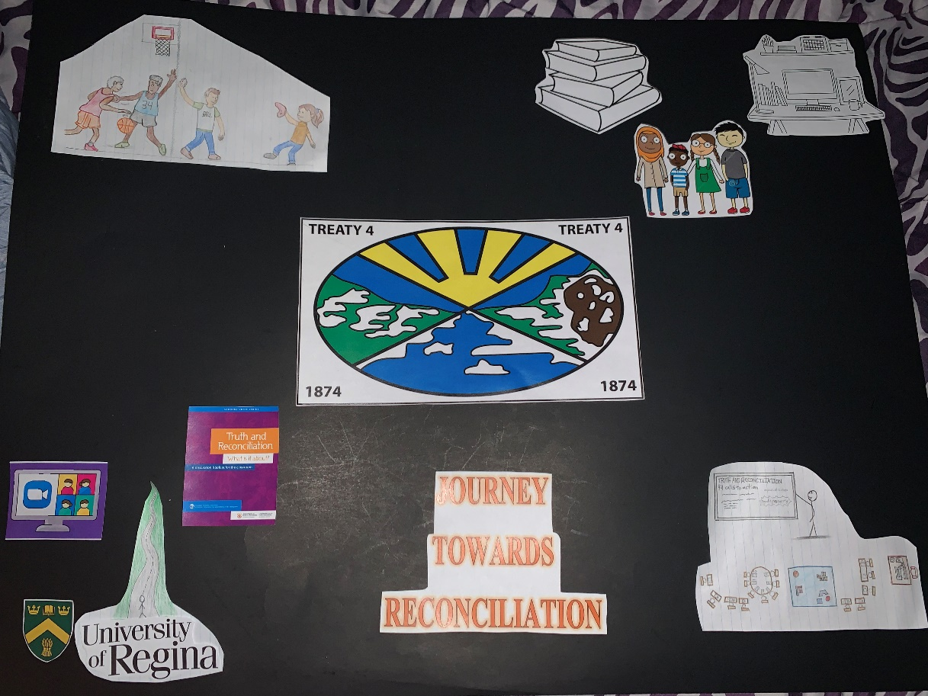

In my aesthetic presentation for my Journey Towards Reconciliation I chose to do a poster representing my journey to this point. My visual part of the project is very tied in to my written portion. In my first two visuals I show my growth from a young person with a “us vs them” attitude on race issues to growing older and learning more about the world. I learned about difference perspectives from media, books, and meeting new people and this helped changed my mind set to an open one. My third image portrays how university is just the beginning of my journey towards reconciliation and my journey towards becoming an educator. My last image portrays my ideal future classroom, an inclusive open classroom environment. It also represents where I hope to be in my future in teaching. I have also included the flag for Treaty 4 land in the middle as my journey has been entirely on Treaty 4 land. **(The whiteboard on the last visual shows “equality vs equity” and “www.otc.ca” just a bit hard to read. Thank you!)**