Subject/Grade: Science/ELA/Gr. 6 Lesson Title: Popsicle Stick Chain Reaction Teacher: Jenna McAuley

Stage 1: Identify Desired Results
Outcome(s)/Indicator(s):
ELA CC6.9 Prepare a teacher-guided inquiry report related to a stand on a topic, theme, or issue studied in English language arts.
(a)Use inquiry to extend understanding of a particular topic related to the themes and issues being studied as follows
- generate key research questions to guide inquiry and seek required information and data from a variety of sources (e.g., observations, interviews, print, electronic, and video resources)
- create and follow a plan to collect and record information within a pre-established frame
- relate gathered information to prior knowledge to reach conclusion and develop point of view
- use the language of inquiry (e.g., "I wonder if...", `What do I want to find out?', `What do I need to do next?').

Key Understandings: (‘I Can’ statements):  I can create a chain reaction using tongue depressors.  I can describe what tension feels like.  I can use techniques to prevent a reaction from going off.  I can experiment with the reaction and length to see what shorter and longer reactions look like or if they work at all. | Essential or Key Questions:  How can I place tongue depressors together to create a reaction?  Why do the tongue depressors react in the way they do after being let go?  How does a different length of ladder yield a different result?

Prerequisite Learning:
N/A

Instructional Strategies:
Demonstration- Show students how to create the reaction ladder at the front of the class and have an example on display so students know how to put it together.
Inquiry- Students can explore different lengths of the reaction on their own time and they can create strategies to get it to be the longest that they can.

Stage 2: Determine Evidence for Assessing Learning
Formative – Walk around the room and assess understanding by observing if each pair of students understands how to create the ladder for a reaction.

Stage 3: Build Learning Plan
Set (Engagement): Length of Time: 10 minutes  Show students what we will be doing by setting up an example. Go through how the sticks will be placed and where do hold to make sure it doesn’t come apart. Also show them how to place a stick to keep the reaction from going off in case they need to let go of the sticks. Once the sticks are all placed have students back up and let the reaction go off.  How to place the sticks:  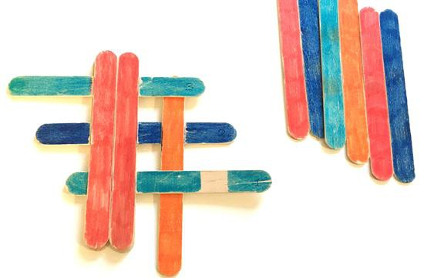  Slide one stick in so it is under sticks 1 and 3 but over stick 2.  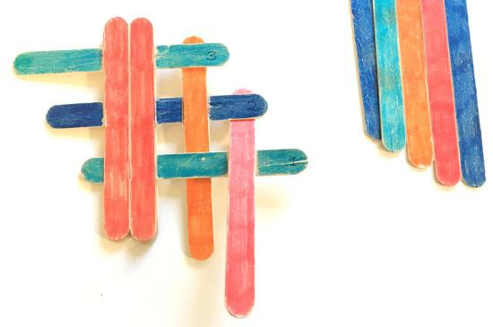  Slide one stick in so it is under stick 2 but over stick 1.  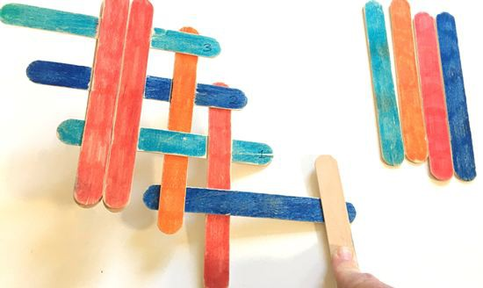  Slide one stick in horizontally so it goes under the first stick placed and over the second stick placed.  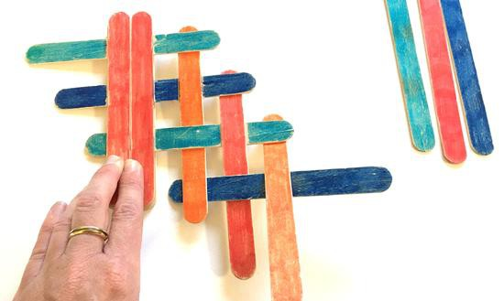  Slide a stick in vertically so it goes under stick 1 and over the horizontal stick we placed.  Repeat this until it is at the desired length always holding the last intersection so it does not come apart.  To place a stick to hold it in place, after placing a horizontal stick, slide a stick in so it goes under the second last horizontal stick and the last vertical stick, but over the last horizontal stick.  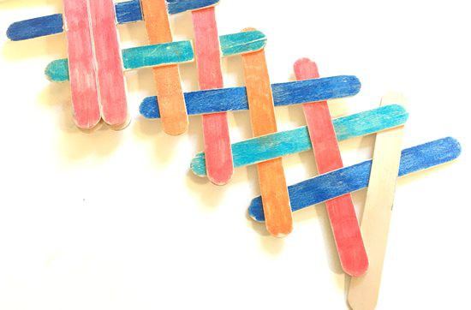  Development: Length of Time: 20 minutes  Allow students to get into groups of 4. Create the groups using Mrs. Mackay’s sticks if necessary and hand out a starter piece to each group. Also give them a handful of tongue depressors and a steps handout. Allow them to work on creating their own reaction. They can choose the length. Have more tongue depressors to hand out as necessary. Make sure each group member gets a chance to build the ladder. After letting students explore for about 10-15 minutes, give the students 2 minutes to create the longest chain that they can. Combine groups of 4 into 2 or 3 larger group. This can be a race against the other groups to see who can make the longest chain. At the end of the five minutes, determine a winner, if there is one, and have each team set their reaction off one at a time. This can be done more than once if there is time.  Learning Closure: Length of Time: 10 minutes  Give students time to clean everything up and sit back in their seats. Once everyone is sat back down, ask if they noticed if the sticks flew more when they used more sticks or less sticks or if it was the same. Also ask them how they think this experiment worked or why the popsicle sticks flew when they were let go. Get some answers from the class. Then discuss how it felt putting the sticks together. Did they have to do anything in particular to get them to fit? They should’ve needed to bend them to get them into place. Talk about the shape of the sticks. The sticks are straight. If they are being bent, what will they want to do to get back to the original shape. Explain that we were creating tension in the ladder. Every time we put another stick in, we added more tension because the sticks want to be straight. When we let go the sticks would fly into the air because the tension was releasing and the sticks were straightening out in a chain reaction or one after the other. | Materials/Resources:  - Tongue depressors, at least 50.  - I will create the starting pieces so we do not have to wait for the glue to dry. We will need at least 6 starting pieces, one for each group of students.  - Glue in case we need to create more starter pieces.  - Building steps handout  Possible Adaptations/  Differentiation:  - If tongue depressors are not available, large somewhat flexible craft sticks are a good alternative. Avoid the thicker, more rigid popsicle sticks.  Management Strategies:  - Use a brain break after the lesson to refocus students.  Safety Considerations:  - Make sure students are aware of flying sticks and back up when they release their own.
Stage 4: Reflection

PROFESSIONAL GOAL SHEET

Name: ________________________ Date: ________________________

Topic: ________________________ Cooperating Teacher: ________________________

Professional Goal  Set & Closure | Steps to Achieve: (describe set and closure)  At the beginning of the lesson, I will introduce the activity by performing it for all the students to see. I will engage the students and teach them how they can do this themselves.  At the end of the lesson, I will create a discussion for students to review the things they discovered during the experiment. I will use questions to guide the conversation.

Instructions for Observer:

 | Yes | No | Evidence
Set

Was the set interesting/engaging?

Did the set capture the students’ attention?

Did the set prepare the students for the lesson?

Was I confident in my presentation of the set?

Closure

Did I bring the lesson to a logical conclusion?

Did I review what the students were to learn?

Did I go over any new ideas in a way that was easy for students to understand?

Notes:

