Journey Towards Reconciliation

Jordy A. McEachern

University of Regina - Faculty of Regina

ECS101-010 012

Dr. F. Pirbhai-Illich

March 28, 2022

# 

# Journey Towards Reconciliation

**Truth and Reconciliation**

A journey towards reconciliation isn’t one-stop and done. It is a messy, but beautiful journey that will hopefully lead to a better future in our society. I can recall my own reconciliation journey beginning around grade one. No, I didn’t know the entire truth about Indigenous people at that young of an age, but learning about Indigenous history all began then. It wasn’t till grade six in my elementary years that my reconciliation journey truly took off. I was being introduced to so much more about the truths of our history with the Indigenous people from their perspectives. By the eighth grade, my class took part in “100 Days of Cree” a book by Arok Wolvengrey and Neal Mcleod where we were bringing Indigenous culture and language back into our very own classroom. From my time in high school to my current time in university, my understanding and condolences to the Indigenous people have grown more and more. Through this course, I have been allowed to continue my journey to reconciliation, and review my part in the world as a future educator in the education system we live in today.

**Decolonizing Education**

Growing up most do not realize the way our education is set up. Before taking any Education of Justice course this year, I had limited knowledge regarding white privilege, but now adding what I have learned from this course has deepened my understanding. White privilege is having the ability to inherent advantages possessed by a white person based on society’s racial inequality and injustice. White privilege isn’t just a matter of being discriminated against or not, but it can also play a role in our education system. Our education system was developed through the eyes of western values, and not Indigenous nor those of other races, or ethnicity. Decolonizing is a “process of undoing colonizing practices.” (Decolonization in an educational context, 2022) As a future educator, there is so much my role can contribute to decolonizing the education system that was set in the past to make it more culturally inviting to all. Allowing every student to connect with their studies based on their culture, languages, and experiences. When reflecting on my knowledge of having an education system based on whiteness, it is clear to see how the system we are currently running isn’t allowing for any equity within the classroom environment.

**Medicine Wheel in Education**

The medicine wheel is a component I strongly believe to be helpful in reconciliation. As “The Wheel is a good representation of how Indigenous people see the world, especially how different things are interconnected.” (Understanding reconciliation with Aboriginal people using the medicine wheel, 2020). This allows the Indigenous culture to be brought into the classroom, and for all students to be able to use it on reflection of themselves. From my own experience throughout elementary and high school, this was always used within the school, and if not it was directly in my classroom in poster form on the wall. Teachers I had throughout my education had always used it for reference, and when reflecting on situations within the class, or ourselves. I chose for my representative piece to focus on the medicine wheel as it is something I hope to bring into my classroom that I can allow for cultural equity for all my students. Within the medicine wheel, we have the opportunity to reflect on our past, present, and future as not only individuals like I had said, but to reflect on our country, governments, or society’s actions. Various occurrences have happened to the Indigenous community such as residential schools, where children were ripped from their homes and demanded to learn a Western-European education and not have any relation to their own culture. As much as residential schools no longer exist, Indigenous children are still having to go to a school and receive education in a Western-European-based system. Of course, residential schools haven’t been the only thing they’ve suffered, there is as well, MMIW (Missing and Murdered Indigenous Women), society inequality, racism, colonization, loss of land, and freedom. So much has happened to their entire community around our country, and that is where I believe that all these occurring events from the past to the present can be reflected in my future classroom with students or even coworkers. 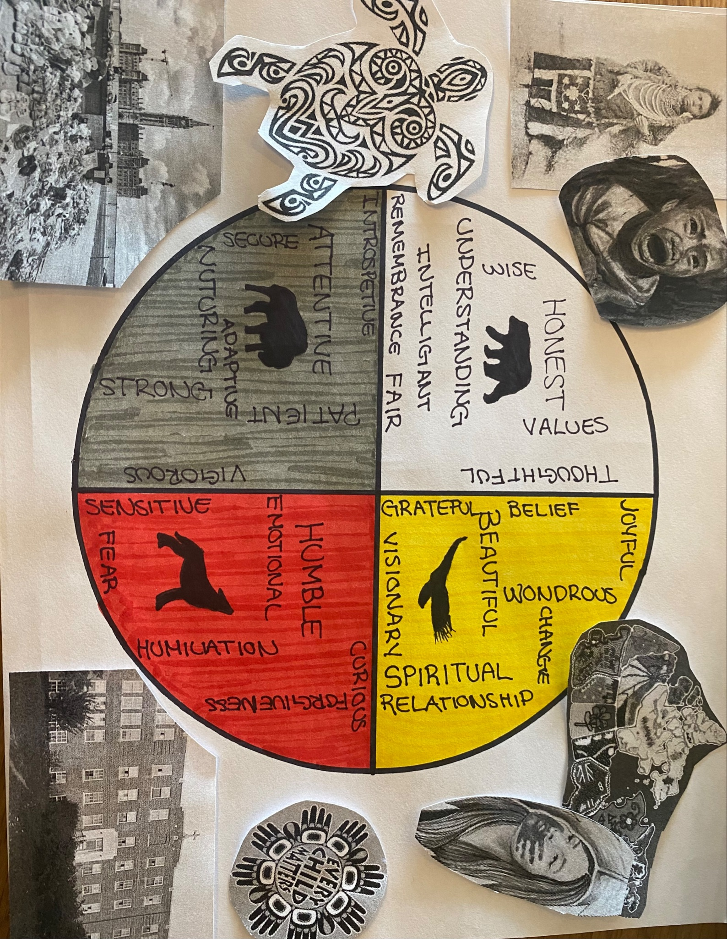

**Indigenization in the Classroom**

My journey toward reconciliation has continued to grow throughout this course as my knowledge about in-class learning has been able to open to see the diversity and differences within the classroom. Not every student is the same, therefore not every student comes from the same background or culture and that is where my role is crucial as an educator. It is then my responsibility to prepare myself for any possible student that could enter the classroom. There are various ways that one educator can bring Indigenous culture, or teachings into their classroom. One way I believe in finding and showcasing books filled with Indigenous stories of any kind around my classroom so there is that ability to have understanding and equity amongst all students. Another is once again the medicine wheel, this medicine wheel has so many abilities, another of which I believe can create a holistic environment. All four quadrants of the medicine wheel connect in a type of cycle to shape the development and reflection of students rather than just one perspective. Bringing this into the class is what I believe is a way to resist the Indigenous children’s feelings that were placed in an article from class that said, “When teachers do nothing, Indigenous children don’t see themselves in their classrooms, and non-Indigenous children do not learn about this land’s first – and continuing – inhabitants.” (Dr. Kate Freeman, 2019). This allows for non-indigenous children to feel as the Indigenous culture and perspective are worth less than their own, which it is not. I want to use the four quadrants to create a safe and welcoming space for students to feel comfortable to be vulnerable in their education, and that their own culture is just as important in their education. I hope that using these various ways of Indigenous values will allow my classroom to be accepting of all students’ differences, diversities, and minorities; so the future program and classroom I am educating students on can correspond to all.

**Continuation of Truth and Reconciliation**

Over the semester I have been able to expand my Truth and Reconciliation journey in various ways. By learning and deepening my understanding of the education system we follow to this day, and how it is based on Western European values that neglect the ways and teachings of the Indigenous culture. Knowing this information I want to know this and go into my future courses, and future classroom and be able to incorporate Indigenous values, beings, and teachings into it. Since every person has the ability to reconcile but what I have read from the STF (Saskatchewan Teacher Federation) “Teachers have a unique opportunity to contribute by advocating for change to eliminate inequality and racism.” (Understanding and Finding our way, 2022) and this is what I believe will make a huge change in reconciliation and my journey to Truth and Reconciliation.

# 

# References

Dr. Kate Freeman, S. M. D., Lopez, by: D. A., by: Dr. Kelly Gallagher-Mackay, C. C., & Lamoureux, by: K. (2019, July 16). *Truth and reconciliation in your classroom*. EdCan Network. Retrieved March 16, 2022, from https://www.edcan.ca/articles/truth-reconciliation-classroom/

*Decolonization in an educational context*. (n.d.). Retrieved March 27, 2022, from https://www.uvic.ca/research/centres/youthsociety/assets/docs/briefs/decolonizing-education-research-brief.pdf

*Understanding and finding our way*. Saskatchewan Teachers' Federation. (2022, March 23). Retrieved March 21, 2022, from https://www.stf.sk.ca/education-today/understanding-and-finding-our-way

*Understanding reconciliation with Aboriginal people using the medicine wheel - free essay example*. EDUZAURUS. (2020, December 24). Retrieved March 25, 2022, from https://eduzaurus.com/free-essay-samples/medicine-wheel-reconciliation/