Name: Kara Miskolczi

EMTH 200 Assignment #5: Micro-Teaching Template:

Mathematical Topic: | Grade: 11
Saskatchewan curriculum outcome(s) (may include one or two indicators)
- P20.7 - Demonstrate understanding of quadratic functions of the form y = ax² + bx + c and of their graphs, including: vertex, domain and range, direction of opening, axis of symmetry, x- and y-intercepts.
E. Develop, explain, and apply strategies for graphing functions of the form f(x) = a(x - p)² + q by applying transformations related to the values of a, p, and q.

Source of Task (Author, title, and page #; or URL)
Kara Miskolczi – self created task

Description of Task (this can be copied directly from the source – I just need to know what the task is)
Students will be introduced to the Vertex form of the quadratic equation. They will be given a laptop or tablet equipped with Desmos graphing calculator (or other graphing calculator). Using Desmos, students will Graph the given equations and come up with definitions for what type of transformation each letter represents.
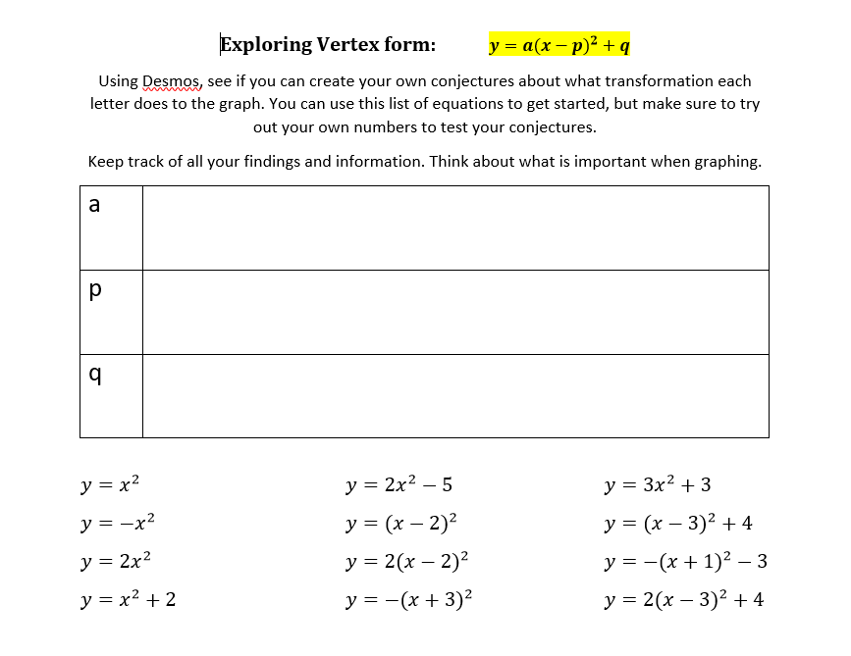

Why have you chosen this task?
Suppose you were explaining why you chose this task to your principal or to a parent. How does this task connect to the curriculum outcome(s)? How does it engage students in problem solving? What will students learn?
I chose this task because over my years in math and tutoring high school students, most have trouble understanding how transformations affect the graph. This is an important part in understanding how to graph in efficient ways. The outcome and indicators listed above are specifically about understanding how each part of the equation affects the way the graph looks. The task given engages students in making their own conjectures and understanding transformations in their own way. Students will learn through experimentation and testing conjectures about how each part of the formula affects the graph. I think that by having the students investigate it for themselves instead of told what it means, they will better understand transformations.

Required Resources & Materials for this lesson
Technology (tablet, laptop, graphing calculator) for each student, or if put in groups, one per group. Access to the internet – Using Desmos, or another graphing calculator
Worksheet – from above
Projector/smartboard – you can demonstrate to the class using the same technology they will be using.

How will you introduce the problem task to the students?
Students will have a base knowledge about graphing parabolas and transformations on a linear equation. I will review what transformation means before anything. I will then go through an example of the transformations. I will start with x^2 and move to x^2+1 and (x-1)^2 just to get them started on what the task is asking us to do. I will also talk about how students need to test their theories on the transformations.

Possible difficulties
What kind of mathematical difficulties might students run into as they work? What nudges might you offer to help students focus their efforts more productively on the math concepts?
I think the stretch of the graph (a value) would be a difficult one to define. For this I would ask student to look at how the coordinates of a graph changes.
It might be hard for them to figure out where to start and then how to transform the graph. For this, it would be reminding students to start with the base graph (x^2). Then transform from there. Take it one step at a time, one transformation at a time.
I think students need to understand to look at the coordinates by seeing how the x and y were affected. Looking at the changes from one graph to another will be the major part of making this task successful.

Possible solutions
List possible solutions (both correct and incorrect) for this task that you anticipate students might develop.
There are many possible solutions both rudimentary and fully developed:
Possible answers include:

A= the flip of the graph, this value multiplies the y coordinate, stretch and reflection (affects the y-coordinate)

P= moves the graph to left or to right, side to side movement, horizontal movement of the graph, affects the x-coordinate

Q= up and down movement, vertical movement of the graph, affects the y-coordinate

How will you assess the students’ level of understanding?
How will you know how well a student understands the concept (as defined by the curriculum outcome)? What kind of mathematical behaviour will you be looking for while they’re engaged in the task?
If the students can correctly identify how each variable affects the transformation of the graph, and give reasons to support. The main thing I am looking for is their ability to figure out what the transformations mean. It is also important that they explain where their thoughts came from – this means that they will be using previous knowledge from earlier in the year.

I am hoping students engage in the process of hypothesis testing, graphing, understanding parabolas, and using different strategies we used in class. Make conjectures and testing them is a major part of problem solving and logical thinking.

