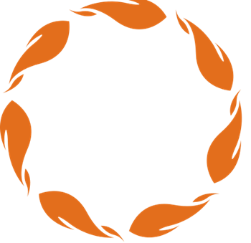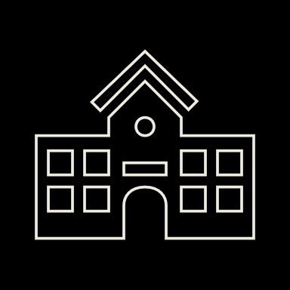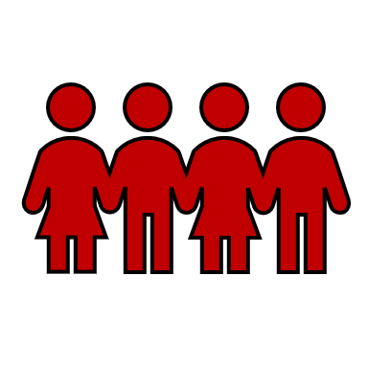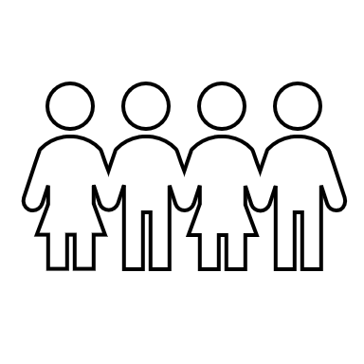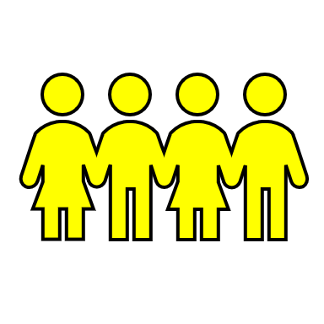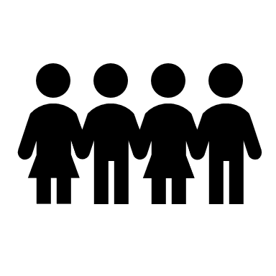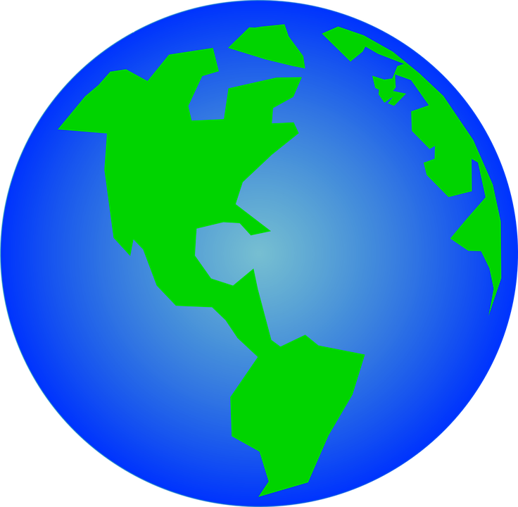

A World of Truth & Reconciliation!

**Interconnection of Knowledge, Schooling, and Society**

The arrows represent the flow of relationship and interconnection needed between school, students, parents, and community, so that the whole child is taught with inclusion of all differences of sex, gender, ability, culture, race, etc. How they are taught—pedagogy, and what they are taught—curriculum.

**STUDENTS** however, are central to the interconnection of knowledge, schooling, and society. Without children the system would collapse. Therefore, how we teach and what we teach needs to meet the needs of ALL students and who they are holistically because then ALL benefit from the student to society and everyone/thing in between; reflecting the society we want tomorrow.