Subject/Grade: Health/Grade One Lesson Title: Mirror Box Activity Teacher: Shana Blenkin

Stage 1: Identify Desired Results
Outcome:
USC1.5- Explore the association between a healthy sense of "self" and one's positive connection with others and the environment.

Indicator: (b) Recognize “self” as an individual who has particular physical and inherited attributes (e.g. height, freckles) and particular experiences that may or may not be similar to those of others. (e.g. traditions).

Key Understandings: (‘I Can’ statements)  (Put the key learnings into student-friendly language that begin with ‘I can…’. The students should know what these are at the beginning of the lesson. An example is: I can express conclusions about the success of two different health promotion strategies. Doing this helps student engage in the learning since they know what it is that they will/need to learn).  I can see what makes me different  I can pick out one thing that I love about myself (physically)  I can see what makes my friends different or unique  I can see what makes us the same  I can say nice things about my peers different features or culture | Essential or Key Questions:  (What are three to four deeper learning questions that you want to make sure you ask during the lesson – write them out here – this will support you in asking purposeful questions during the lesson)  -What does unique mean?  -What makes you unique?  -What makes your friends unique or different from you?  -What makes us the same?

Prerequisite Learning:
(What are some concepts, facts, and/or skills that students must already know/understand/be able to do in order to ‘learn’ what you expect of them today? An example is: what health promotions strategies are.)

Students previously have shared and discussed their family backgrounds and where they came from.
Students have done a “family tree” activity to get to know each other in our class. The students brought a picture of their family and a write up about their culture/traditions/foods/background. This is displayed in our classroom in our family corner.

Instructional Strategies:
(What strategy(ies) will you use throughout the lesson to engage students in the learning process?)

Large group discussion
Graphic organizer
Hands on activities

Stage 2: Determine Evidence for Assessing Learning
(Identify your plans as either Formative and/or Summative and provide a brief description of what you will do to gain some form of evidence towards the O’s and I’s above, towards the ‘I can’ statements, towards the Key Questions. ALL of these should all connect together and reflect each other!)

Pre assessment- formative – During the lesson I will be asking questions and getting students to brainstorm answer to “what makes us unique, how are we different from our peers, is it ok to look different from each other, what is something that you love about yourself?”

Post assessment- Summative- Students will write down on their graphic organizer sheet 5 things that make them unique/different or what they like about themselves. (see appendix c).

Formative- At the end of the lesson, students will have a chance to share their self-portrait and describe verbally what they find unique about themselves.

Stage 3: Build Learning Plan
Set (Engagement): Length of Time: 15 Minutes  (Get their attention! And then tell them what you are going to learn through this lesson)  The students will gather in the reading corner and the teacher will show the mystery box and say, “everyone will get a chance to see what is inside the box, and everyone will see something different. Do you know what is in the box?” Have students guess what they think might be in the box. (3 minutes)  The teacher will read aloud “I Like Myself” by Karen Beaumont. After reading the story discuss with the students in the large group if they know what it means to be unique. Write UNIQE on the whiteboard and write down ideas that the students say. While doing this I will talk about my unique features – blonde straight hair, freckles, blue eyes, skin color, etc. (5-10 minutes)  Development: Length of Time: (25 Minutes)  (Remember, everything you do here needs to align with the identified O’s and I’s and support the students in answering the key questions as well as reaching the ‘I can…’ statements).  Call students up one at a time to look into the mystery box, remind them not to say what they see until everyone has had a chance to look. After they have looked, they will go back to their desks/tables.  Hand out the graphic organizer sheet and have students write their name in the middle of the sheet and fill out the 5 bubbles with features about what they saw when they looked into the mystery box. Have extra mirrors available if the students want to look at themselves more while doing this part of the activity. The students will show you their 5 features before creating their self-portrait.  The students will pick a coloured piece of paper that they think best represents themselves. The students will finish decorating the paper using markers, pipe cleaners, yarn, buttons, Etc. This is a fun activity for the students to use their imagination with the tools provided to create a picture of how they want to represent themselves. Example: blue buttons for eyes, yarn for hair, etc.  Learning Closure: Length of Time: (10 mins)  (Do some form of ‘check for understanding’ and tell them or have them tell you what they learned today. This can be done using a variety of strategies).  The students will have a chance to share their finished self-portrait if they want to and they can explain what makes them unique and what they like about themselves. For the students that do not share aloud I will ask those students questions about their self-portrait when I pick up their pieces. Their self-portraits will be displayed on a bulletin board in our classroom. |  | Materials/Resources:  I Like Myself book  Box with question marks marked on it  Mirror (inside of box) +one mirror for each table or cohort group  Printed outlines of a face/head on different skin toned coloured paper (students can have the option of what coloured paper they want to use). (See appendix A.)  Crafting Material- Yarn, pipe cleaners, buttons, markers, glue, stickers, leaves etc.  Graphic organizer sheet (see appendix B.)  Possible Adaptations/  Differentiation:  The students could color their self-portrait instead of using craft material.  The students could pairs up and create a self-portrait of their peer/cohort. They are recognizing what is unique and different about their classmates.  Have a premade graphic organizer and self-portrait of myself for students to see a visual of the task they are given.  Management Strategies:  Criss Cross applesauce, mermaid, or mountain sitting during time in reading corner.  Call students to look in the box based on t-shirt color or birthday month they are born in, to avoid conflict on who looks first.  Timer set for students to visualize how much time they have to work on their self-portrait  Safety Considerations:  This could be a sensitive subject if the students do not recognize what they love about their appearance.  Mirrors breaking
Stage 4: Reflection
(This part of the lesson is completed after the lesson has been delivered; this is where you can record how it went, what you would keep, and what would you change for next time)

Appendix A.

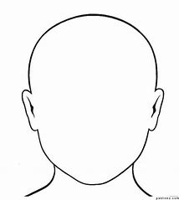

Appendix B.
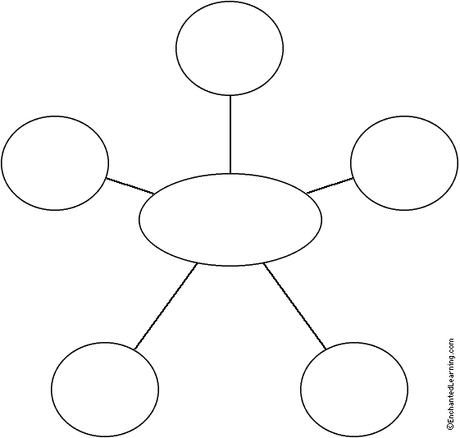

Appendix C.

Summative Assessment Check List: Mystery Box Lesson Plan

Students Name: | Questions: | Rating:
Student A | Can the student list 5 unique attributes of self: | 1 2 3 4 5

