Name: Meegan Svedahl and Sydney Schnell  Subject: Math | Date: October 16th, 2019  Grade: Kindergarten

Essential questions (overall unit):  What is a pattern? | Guiding questions (specific to lesson):  What is an AB pattern?  Can you recognize an AB pattern?  What parts of the pattern repeat?  Can you trace/copy an AB pattern?  Can you finish an AB pattern?  Can you make your own AB pattern?
Outcomes:  PK.1  Demonstrate an understanding of repeating patterns (two or three elements) by:  - identifying  - reproducing  - extending  - creating  patterns using manipulatives, sounds, and actions. | Indicators:  -Identify the parts of a pattern that repeats.  -Copy a repeating pattern and describe the pattern (actions, sounds, shapes, size etc)  -Extend repeating patterns by 2 or more repetitions.  -Create a repeating pattern using sounds, actions, manipulatives etc.  -Identify a repeating pattern.

Assessment Strategies:
The students will be formally assessed throughout the lesson by having them answer questions regarding patterns, and what AB patterns are.
They will also have a worksheet to finish a pattern, copy a pattern and make their own pattern. These worksheets will be collected at the end of the lesson and used as a formative assessment.
When the students are making their pattern they will have their choice between using paper provided or using manipulatives, if they choose to use manipulatives there will be pictures taken on See-Saw so we can refer back to them in regards to assessment.
Instructional Strategies:
The set of this lesson will be in a more direct manner.
For the development, students will have exploration time and students will be selected to come to two 5 minutes stations. One station will be with Sydney, the other will be with Meegan. 5 students will come at a time to a mini lesson. The mini lesson will have some direct instruction, as well as hands on manipulation. With little guidance students will work through a few different worksheets/ tasks at the stations using manipulatives, or writing utensils.
Adaptive Dimensions:
We will have an example of each worksheet and pictures for instructions for those who do not speak/understand English.
We will also have worksheets where the students can trace/ copy patterns if they are not quite at the stage of finishing a pattern or making their own.
We will have a variety of manipulatives for hands on learning for the students to use when copying or making their patterns.

Materials Needed:
-Bear manipulatives
-Markers
-Scissors and glue
-Pattern book
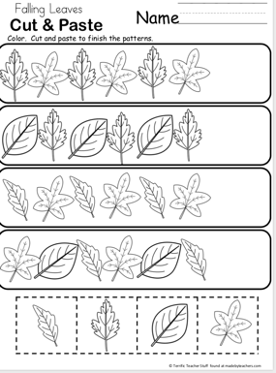
This worksheet will be used for students to complete the pattern shown.
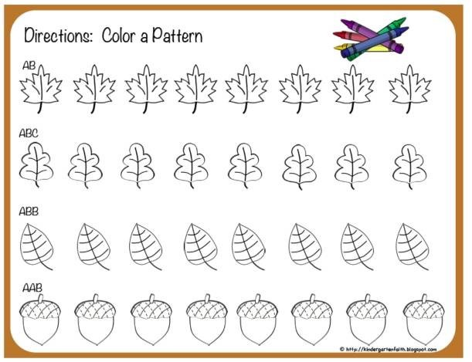
Students can use this worksheet to create their own pattern.
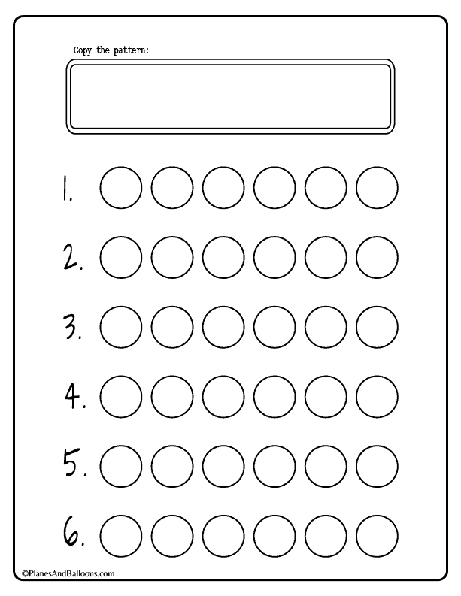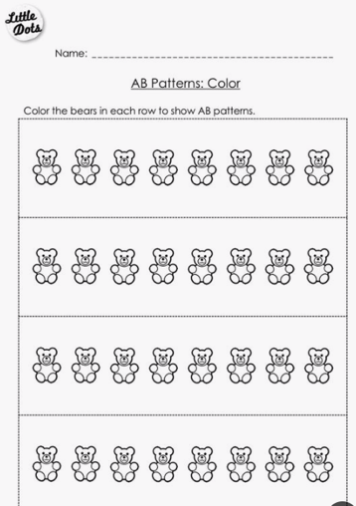
These two worksheets can be used for students to copy an AB pattern, or make their own
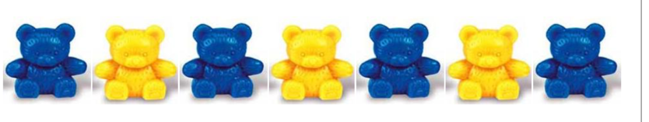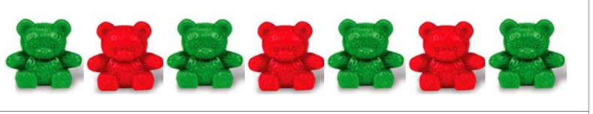
-These cut out AB patterns will be used for students to copy using manipulatives, as well as copy onto a blank sheet.
Prerequisite learnings and Preparations:
-Some understanding of what patterns are, specifically AB patterns.
-Time to play with the manipulatives so they are less distracted when working with them.
Set:
We will begin by introducing that we are doing patterns. (Hey friends, today we are going to talk about patterns. Do you know what a pattern is?)
We will then read the pattern book they already have discussing the different patterns on each page.( Let's read the pattern book to learn a little bit about patterns).
After we go through the book once, we will go back through. We will start with the pattern on the first page and add a sound to each part of the pattern. We will then go through the pattern making the sounds accordingly (eg. boom, click, stomp, thhh etc.) (Now we are going to go over the pattern making sounds. This one will be __ sound and everytime we see it we will make that sound… lets go over the pattern with the sounds)
We will then go to the next page and do the same thing with the pattern however this time with actions. Each part of the pattern will receive an action (eg. stomp, clap, jazz hands etc.)
We will then tell the students they have exploration time and will be coming in small groups to learn more about patterns with the teachers.
Development:
The students will have exploration time. At the start of this time Meegan will take the first 5 kids. Sydney will help children transition into exploration time.
Meegan will call the first group of 5 people and take them to the set up station. This station will include: the cut out coloured AB pattern bears, the worksheet of outlined bear, the empty dot worksheet (if time permits) and the example dot patterns (if time permits).
First Meegan will show students that we will pick a pattern and place the manipulatives accordingly. The students will then pick out a pattern of bears from the envelope. They will be given a selection of bear manipulatives and asked to copy the pattern using the manipulatives. If students get it quickly they can try the other pattern of bears.
Meegan will then show a pattern with the bear manipulatives and the students will be asked to copy the pattern using their manipulatives. If the students find this to easy they can colour the bear outlined worksheet instead of using the manipulatives. Meegan will show 3 patterns.
If there is time still left in the rotation students will pick a circle pattern from the envelope, and be asked to copy the pattern on the empty circle worksheet.
When students are done 5 minutes at Meegan's station they will go to Sydney's station for 5 minutes. Meegans station is seen as a progression to Sydneys. Meegan will then call the next group. Meegan will finish 5 minutes before Sydney to help with clean up.
Once the children transition to Sydney’s station they can get started. This station will include: the worksheet designed for students to try and guess which part of the pattern comes next, scissors and glue for students to cut out and glue the symbol, shape or object they think comes next onto the worksheet (if time permits), the full worksheet of different objects in rows where they can cut out and make their own pattern, and manipulatives they can use to show their pattern as opposed to using the worksheet if they choose.
Sydney will give the students the worksheet and ask students which symbol or object they think comes next. They will then be asked to cut out and glue that particular picture of the object onto the continuing pattern. There are three questions that are similar, if they get these three without guidance Sydney will ask them to do the fourth question by themselves, which is more difficult, will give guidance if needed.
After these questions are completed, Sydney will then ask the students to cut out the rows of the same objects they like and try to create their own pattern. Students will have their choice between worksheet objects or the use of concrete manipulatives to show their own pattern. If time permits and/or if students find this too easy students that are using the worksheets can colour their objects and create a new pattern based on colour rather than object.
Closure:
After all students have participated in each mini session we will ask them to come back to the rug in the middle. (Hey friends, we are all done, let’s come back to the carpet together!)
We will ask the students what they learned about patterns in the sessions and see if any new words come up (Did anyone learn something new about patterns or want to share what they did with the teachers?) We will then play a small game with the students that is more student led and they will have more choice in it.
We will ask the students to think of two sounds we can use and two actions that we can use. We will put one action to each sound they have chosen as a group. (ex: jazz hands with the sound boo, clap with the sound of humming, etc.)
We will perform one action with the sound and then the next action with the sound and ask them what would come next. (Hey friends, let’s clap and hum and now try jazz hands and say boo, now what would come next...)
We will then ask them to perform the pattern of actions and sounds all together on their own for us. (Can you show us the pattern this time all by yourself?)

Students: | Professional Target Goals:
Meegan | Throughout this lesson my goal is to work on speaking clearly and concisely. Often times I talk to fast which makes what I'm saying hard to understand. I also have trouble with concise instructions and often ramble. In this lesson my goal is to speak slow and clearly so all students can hear and understand to the best of their abilities, as well as give short simple instructions.

