Name: Meegan Svedahl  Subject: Social Studies | Date: Nov 6th, 2019  Grade: Kindergarten  Lesson: 1

Essential questions (overall unit):  What is a peace? | Guiding questions (specific to lesson):  What does peace look like?  How does peace make people feel?  Does peace always look the same?
Outcomes:  PAK.1  Understand and respect the agreed-upon rules of the classroom, playground, and school, and recognize that rules and expectations are designed to promote a state of safety, self-regulation, peace, balance, and harmony. | Indicators:  Recognize that appropriate behaviour differs depending upon the setting.  Identify people who make rules that influence students' lives, and discuss the types of decisions made by self and others.

Assessment Strategies:
I will ask questions throughout and take note of the students who are answering and engaged in the discussions.
They will then draw a picture after to show what makes them feel peace. They will hand this in as formative assessment on what peace is to them. I will also walk around the room when they are working and jot down what they think peace is (aka what they are drawing) so when I review them I can better understand their work.

Instructional Strategies:
Direct
-I will read the students the book pointing out key points while engaging students throughout.
They will then work independently on a picture.
Adaptive Dimensions:
I will demonstrate the drawing of something that makes me feel peace so everyone can better understand the assignment.
I will walk around when with the book when the students are working. If they seem to be lost I can show them picture in the book to try to help them understand.
When reading I will try to read slow for better understanding.

Materials Needed: `
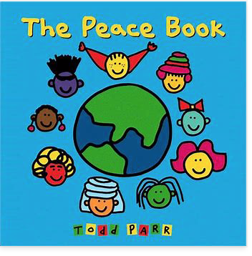
The Peace Book By: Tom Parr
Paper for everyone
-pencil crayons
Whiteboard/markers

Prerequisite learnings and Preparations:
Some understanding of what peace is, and when we see peace.

Set:
We will start by brainstorming what peace means. I will ask the students if they know what peace means and write the what the students say on the board.
Hey friends today we are going to talk about peace. Do you know what peace is? Lets make a list of all of our ideas, Ms.S will write them on the board, but lets put up out hand and go one at a time. Great thinking friends.
We are now going to read a book about what peace can look like.

Development:
I will start by reading the title and author of the book.
2nd page:
-When the water is clean for the fish to live in that is an example of peace.
3rd
-Do we think these friends are listening to the same music? Probably not but they both look really happy.
4th
-Even if it’s an accident we should always say sorry, right.
7th
-Like thinking about your dog, your family or friends, that’s peace.
8th
-Do you think the worm felt good when people shared their shoes? This is peace
10th
-How do they look after sharing a meal? They look happy because they were sharing, this is peace.
12th
-How do you feel when you watch it snow? Some people feel peace.
13th
-We can keep the streets clean by throwing away our garbage.
16th
-even the animals have homes, the spider, dog, fish and all the other animals in the world. That is peace.
20th
-Sharing with others is an example of peace.
25th
-Seeing new things is an example of peace.

After we read the book we will move right into the next activity to keep their attention. I will explain that we are going to draw a picture of something that makes us feel peace. Maybe it will be thinking about your pet, or sharing, or saying nice things. What makes me feel peace is being in my garden, so I will draw a picture of me in my garden.
I will show them on my paper that will be magnet to the board.
Once I show them an example I will have them go in their job groups to complete the task.
I will walk around the room and ensure the students are on task. I will make conversation with students to get to know them, and assess their understanding of the lesson.
Closure:
The students will hand in their picture when they are done and tell me what they drew. The picture they drew will help me see their understanding of the lesson.

Students: | Professional Target Goals:
Meegan | -My goal this week is to keep everyone’s attention during the story. This is something new to me and out of my comfort zone so I hope to have all students (for the most part) on task throughout the book

